1) Run Script “Step1-RunScript” in Mammoth

2) Before running SSIS Package make sure to set correct parameters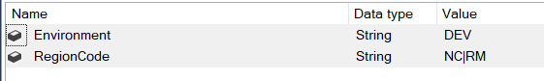



NOTE: Region codes are separated by |

RUN SSIS Package” LoadMammoth-IrmaItemKey”

3) Confirm with QA, if everything looks good, drop table dbo.IrmaItemKeyStaging